web_infrastructure_design

1. Distributed web infrastructure

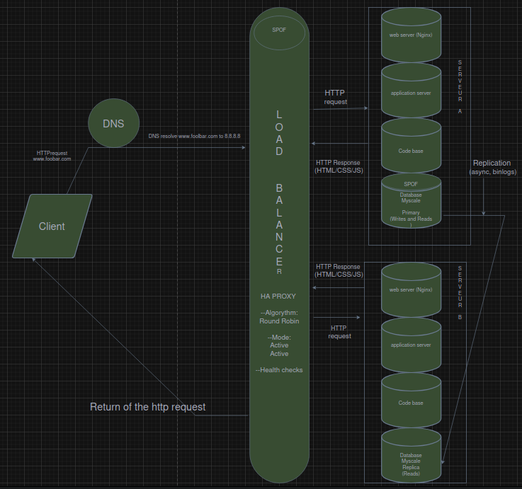

- What distribution algorithm your load balancer is configured with and how it works
My load balancer is configurated with Round Robin algorythm,
the algorythm distributes the requests in a rotating order first server A and then the B after the B it goes back to the A

- Is your load-balancer enabling an Active-Active or Active-Passive setup, explain the difference between both
This set-up is an active/active configuration why ?
both server are working the load balancer distributes the requets on both servers the A is the primary (write/and read) and the B(read/only) if the set up was passive only the server A would receive the request, as soon as the server A is unavailable due to an ddos attack failure or maintenance the server B would do the needful to handle the request and database of server B would be set on write and read instead of read only,

- How a database Primary-Replica (Master-Slave) cluster works
The Master handles all write operations (INSERT, UPDATE, DELETE). The Replica receives a copy of all changes from the Master and handles read operations. If the Master fails, the Replica can be promoted to become the new Maste

- What is the difference between the Primary node and the Replica node in regard to the application
Applications send write queries to the Primary node and read queries to the Replica node. This separates the workload and improves performance
- Explain what the issues are with this infrastructure:

- Where are SPOF
The SPOF are :
- The load Balancer if it fails the trafic will not be redirected between the server A & B

- The mySQL database on server A because this one is set on write/read, if it unable to write no operations can be written which results in a loss of data

- Security issues (no firewall, no HTTPS)
No https to secure the connection
no monitoring
no secure communication between components

- monitoring
No metrics on the serveur component like
ram
hdd
no logs or alerts if the serveur is down

